Family Summer Vacay Packing List 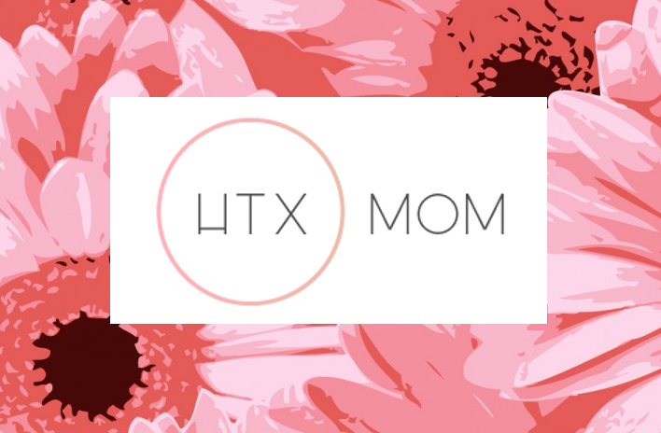

|  |  |  |  |
| --- | --- | --- | --- |
| **PACKING LIST –**  **MOM** | **PACKING LIST –**  **TODDLER** | **PACKING LIST –**  **BABY** | **PACKING LIST - FAMILY GENERAL** |
| **Clothing** | **Clothing** | **Clothing** | **Electronics** |
| Underwear / bras | Underwear / diapers | Socks | Cell |
| Socks | Socks | Pajamas | Laptop / tablet |
| Pajamas | Pajamas | Tops / T-shirts | Chargers |
| Tops / T-shirts | Tops / T-shirts | Bottoms | **Kitchen stuff** |
| Bottoms | Bottoms | Sweater | sippy cup |
| Sweater | Sweater | Jacket | spoon / fork / plate / bowl |
| Jacket | Jacket | Swimsuit / cover-up | snacks |
| Work-out gear | Dress / Skirt | Shoes | bibs |
| Dress / Skirt | Swimsuit / cover-up | **Toiletries** | bottle stuff |
| Swimsuit / cover-up | Shoes | Baby shampoo / Body wash | formula |
| Shoes | **Toiletries** | Toothbrush / Toothpaste | High chair / eating chair |
| **Accessories** | Baby shampoo / Body wash | Hairbrush / Comb | **Miscellaneous** |
| Watch | Toothbrush / Toothpaste | Band aids | Books / e-book / magazines |
| Earrings | Hairbrush / Comb | Diapers, diaper cream, wipes | Headphones |
| Necklace(s) | Hair ties | Sunscreen | Keys |
| Bracelet(s) | Band aids | Bug spray | Wallet |
| Scarf(ves) | Diapers, diaper cream, wipes | Lotion | Cell phones / chargers |
| Belt(s) | Sunscreen | Towels / rags | iPad / charger |
| Purse(s) | Bug spray | Baby pain reliever | DVDs |
| Cap / Hat | Lotion | Swim diapers | Notepad / pen |
| **Toiletries** | Towels / rags | Teething gel / teething ring | Gum |
| Shampoo / Conditioner | Baby pain reliever | Thermometer | Tissues |
| Soap / Body wash | Swim diapers | Change mat | Seatbelt cutting tool / Window breaking tool |
| Razor | Ear medicine | Pacifier | Ziploc bags |
| Toothbrush / Toothpaste | **Sleeping** | **Baby Stuff** | First Aid Kit |
| Deodorant | Pack n play / sleep mat | Wrap / bjorn | Anti-bacterial hand gel |
| Perfume | Pillow(s) | Car seat | Plastic grocery bags / trash bags |
| Hairbrush / Comb | Blanket(s) | Stroller | Passports / Paperwork / Itineraries |
| Hair products | Baby monitor | Burp cloths | Camera |
| Hair ties | Nightlight | **Sleeping** | Electricity converters |
| Moisturizer | **Games & Fun** | Pack n play / sleep mat | Umbrella |
| Facial cleaner | Stuffed animals / lovey | Pillow(s) | Emergency contact list |
| Make-up | Crayons / coloring books | Blanket(s) | Extra water / snacks |
| Blow dryer / straightener | Books | Baby monitor | Ice chest |
| Nail file / nail clippers | Swim floaties | Nightlight | Benadryl |
| Tweezers | Umbrella stroller | **Games & Fun** | Cash |
| Band aids | Car seat | Stuffed animals / lovey |  |
| Vitamins |  | Books |  |
| Pain relievers |  | Swim floaties |  |
| Feminine products |  |  |  |
|  |  |  |  |
|  |  |  |  |
|  |  |  |  |
|  |  |  |  |
|  |  |  |  |
|  |  |  |  |
|  |  |  |  |
|  |  |  |  |